* Copyright for test papers and marking guides remains with *West Australian Test Papers*.
* The papers may only be reproduced within the purchasing school according to the advertised conditions of sale.
* Test papers must be withdrawn after use and stored securely in the school until Friday 1st July 2016.

**HUMAN BIOLOGY**

**Unit 1**

**2016**



**Solutions**

***TIME ALLOWED FOR THIS PAPER***

Reading time before commencing work: Ten minutes

Working time for the paper: Two hours 30 minutes.

***MATERIALS REQUIRED/RECOMMENDED FOR THIS PAPER***

**To be provided by the supervisor:**

* This Question/Answer Booklet
* Multiple Choice Answer Sheet

**To be provided by the candidate:**

* Standard items: Pens, pencils, eraser or correction fluid, ruler, highlighter, ruler.
* Special items: Calculators satisfying the conditions set by the Schools

Curriculum and standards authority for this subject.

***IMPORTANT NOTE TO CANDIDATES***

* No other items may be taken into the examination room. It is **your** responsibility to ensure that you do not have any unauthorised notes or other items of a non-personal nature in the examination room. If you have any unauthorised material with you, hand it to the supervisor **before** reading any further.

***Structure of this paper***

|  |  |  |  |  |  |
| --- | --- | --- | --- | --- | --- |
| Section | Suggested working time | Number of questions available | Number of questions to be attempted | Marks | Percentage |
| SECTION ONE:  Multiple-choice | 40 minutes | 30 | All | 30 | 30 |
| SECTION TWO:  Short answers | 70 minutes | 7 | All | 100 | 50 |
| SECTION THREE:  Extended answers | 40 minutes | 3 | 2 | 40 | 20 |
|  |  |  | Total marks | 170 | 100 |

**Instructions to candidates**

1. The rules for the conduct of Western Australian external examinations are detailed in the *Year 12 Information Handbook 2016.* Sitting this examination implies that you agree to abide by these rules.

2. Answer the questions according to the following instructions.

Section One: Answer all questions on the separate Multiple-choice Answer Sheet provided. For each question shade the box to indicate your answer. Use only a blue or black pen to shade the boxes. If you make a mistake, place a cross through that square, do not erase or use correction fluid, and shade your new answer. Marks will not be deducted for incorrect answers. No marks will be given if more than one answer is completed for any question.

Sections Two and Three: Write your answers in this Question/Answer Booklet.

3. You must be careful to confine your responses to the specific questions asked and to follow any instructions that are specific to a particular question.

4. Spare pages are included at the end of this booklet. They can be used for planning your responses and/or as additional space if required to continue an answer.

* Planning: If you use the spare pages for planning, indicate this clearly at the top of the page.
* Continuing an answer: If you need to use the space to continue an answer, indicate in the original answer space where the answer is continued, i.e. give the page number. Fill in the number of the question(s) that you are continuing to answer at the top of the page.

**Section One: Multiple-choice 30% (30 Marks)**

This section has **30** questions. Answer **all** questions on the separate Multiple-choice Answer Sheet provided. For each question shade the box to indicate your answer. Use only a **blue or black pen** to shade the boxes. If you make a mistake, place a cross through that square, do not erase or use correction fluid, and shade your new answer. Marks will not be deducted for incorrect answers. No marks will be given if more than one answer is completed for any question.

Suggested working time: 40 minutes.

1. In an experiment, measurements are made and the results are recorded in a table. Sometimes there are numbers that are well beyond the range of the rest of the measurements. Such numbers are referred to as

(a) trials.

(b) outliers.

(c) mean averages.

(d) mode averages.

1. A person weighing 115 kg lost 4 kg in a month. What was the percentage decrease of their weight?
2. 7.2%
3. 115%
4. 28.75%
5. 3.47%

**Look at the results table below and answer the question that follows.**

|  |  |
| --- | --- |
| Temperature (̊C) | Enzyme Activity (mg of maltose produced) |
| 10 | 4 |
| 15 | 7.5 |
| 20 | 11 |
| 25 | 14 |
| 30 | 17 |
| 35 | 19 |
| 37 | 23 |
| 40 | 22 |
| 45 | 18 |

1. What type of data is shown and which graph would best represent this data?
2. Discontinuous and bar graph
3. Discontinuous and line graph
4. Continuous and line graph
5. Continuous and bar graph
6. The cell theory could best be described as
7. all living organisms are made up of cells and materials produced by cells.
8. all living organisms are made up of cells and progressively become more complex.
9. the structure of all living organisms and the way they function result from the activity of all its cells.
10. all living organisms cells are small so they can exchange materials effectively.
11. If the concentration of sugar in the solution outside a cell is 10% and inside the cell the concentration of sugar is 0.9%, the cell would
12. Expand and burst
13. Shrivel up
14. Retain its normal shape
15. Lose its sugar content
16. When body systems work together to make sure the cellular environment is kept constant, this is known as
17. cellular respiration.
18. endocytosis.
19. homeostasis.
20. pinocytosis.
21. The two types of carrier-mediated transport are
22. diffusion and osmosis.
23. diffusion and endocytosis.
24. facilitated transport and active transport.
25. facilitated diffusion and osmosis.
26. Phagocytosis is best represented as which of the following transfer mechanisms?
27. Active transport
28. Exocytosis
29. Pinocytosis
30. Endocytosis
31. Which of the following lists best shows the levels of structural organisation of the human body?
32. Atoms, Molecules, Tissues, Organs
33. Cells, Tissues, Organs, Systems
34. Molecules, Atoms, Cells, Tissues
35. Molecules, Tissues, Organs, Systems
36. Which of the following lists best describes the smallest parts of a carbohydrate and a lipid, respectively?
37. Monosaccharides and Triglycerides and fatty acids.
38. Monosaccharides and Triglycerides and nucleic acids
39. Saccharides and Triglycerides and fatty acids.
40. Polysaccharides and amino acids.

**Use the diagram below of a nephron and its associated blood supply to answer the following TWO questions.**

A

B

C

D

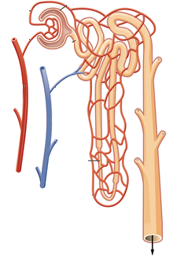

E

F

1. The proximal convoluted tubule is indicated by label
2. A.
3. B.
4. C.
5. D.
6. Glomerular filtration would involve structure(s) labeled
7. A.
8. A and B.
9. D.
10. D and E.
11. Which of the following chemical equations shows the process of deamination?
12. Ammonia + carbon dioxide + energy 🡪 urea + water
13. Oxygen + carbohydrate 🡪 energy + water + carbon dioxide
14. Oxygen + lipid 🡪 carbohydrate + ammonia
15. Amino acid + oxygen 🡪 carbohydrate + ammonia
16. What is present on the surface of rough endoplasmic reticulum?
17. vesicles
18. golgi bodies
19. ribosomes
20. centrioles
21. The white blood cell, red blood cell and platelet, could also be described as:
22. Erythrocyte, leucocyte and thrombocyte.
23. Thrombocyte, leucocyte and erythrocyte.
24. Leucocyte, thrombocyte and erythrocyte.
25. Leucocyte, erythrocyte and thrombocyte.
26. Carbon dioxide is carried in a number of ways in the blood. Which of the following methods is the one that carries the most in the blood?
27. The carbon dioxide is dissolved in the plasma.
28. The carbon dioxide binds to haemoglobin to form carbaminohaemoglobin.
29. The carbon dioxide is carried in the plasma as bicarbonate ions.
30. The carbon dioxide is carried in the plasma as hydrogen ions.
31. Which valve is located between the right atrium and right ventricle?
32. pulmonary semilunar valve
33. tricuspid
34. bicuspid
35. aortic semilunar valve
36. Which of the lists **BEST** describes the **sequential** order of vessels that blood would flow through?
37. Capillary, venule, artery
38. Aorta, capillary, vein
39. Capillary, vein, vena cava
40. Arteriole, capillary, venule

1. A blood sample was mixed with plasma that contained Anti-A and, in a separate test, with plasma containing Anti-B. The blood sample coagulated in the presence of the Anti–A but NOT in the presence of the Anti-B.

The blood sample could be classified into which of the following blood groups?

1. blood type B
2. blood type A
3. blood type O
4. blood type AB
5. Which of the following is NOT a problem associated with the respiratory system?
6. asthma
7. bronchitis
8. pneumonia
9. meningitis
10. Which of the following substances are NOT secreted by cells in a gastric gland?
11. mucus
12. pepsinogen
13. trypsin
14. hydrochloric acid
15. Which of the following respiratory disorders is NOT contagious?
16. influenza
17. pneumonia
18. emphysema
19. tuberculosis
20. The gall bladder stores which chemical and releases it into which organ respectively?
21. gastric juice and duodenum
22. bile and stomach
23. gastric protease and duodenum
24. bile and duodenum
25. The removal of metabolic wastes from the body is best described as
26. elimination.
27. defecation.
28. asphyxiation.
29. excretion.
30. People with coeliac disease are unable to tolerate a protein called gluten. The only treatment is to follow a gluten-free diet. Which of the following foods should a person with coeliac disease avoid?
31. dairy products
32. wheat based products
33. rice based products
34. carbohydrates
35. As substances in the proximal convoluted tubule of the kidney are reabsorbed they move from
36. peritubular capillaries to filtrate, to epithelial cells, to interstitial fluid
37. peritubular capillaries to filtrate, to interstitial fluid, to epithelial cells
38. filtrate to peritubular capillaries, to epithelial cells, to interstitial fluid
39. filtrate to epithelial cells, to interstitial fluid, to pritubular capillaries

27. As blood flows through the glomerulus

1. most plasma proteins are transferred to the glomerular capsule
2. about 20% of plasma is filtered into the glomerulus capsule
3. its plasma volume increases as fluid enters from the glomerular capsule
4. about 20% of the red cells pass into the glomerular capsule

28. Reabsorption of sodium by the kidney occurs in the

1. proximal and distal convoluted tubules only
2. proximal and distal convoluted tubules and Loop of Henle
3. Loop of Henle only
4. Distal convoluted tubule and collecting duct

29. Intestinal absorption of some substances is an active process. This means that:

1. The villi must actually move to enable molecules of food to be absorbed by pinocytosis
2. Products of digestion diffuse quickly across the membranes
3. energy is expended for the absorption of some substances against a concentration gradient
4. The absorption of some substances occurs most readily when there is maximum movement of the intestines

30. The function of the pleural membrane is to:

1. hold the lungs in their correct position in the thoracic cavity
2. help to increase the volume of the thoracic cavity during respiration
3. secrete a fluid enabling the lungs to expand and contract with the thoracic wall
4. help the diaphragm to increase or decrease the volume of the thoracic cavity

**End of Section One**

|  |  |
| --- | --- |
| **Question** | **Answer** |
| **1** | **B** |
| **2** | **D** |
| **3** | **C** |
| **4** | **A** |
| **5** | **B** |
| **6** | **C** |
| **7** | **C** |
| **8** | **D** |
| **9** | **B** |
| **10** | **A** |
| **11** | **C** |
| **12** | **B** |
| **13** | **D** |
| **14** | **C** |
| **15** | **D** |
| **16** | **C** |
| **17** | **B** |
| **18** | **D** |
| **19** | **B** |
| **20** | **D** |
| **21** | **C** |
| **22** | **C** |
| **23** | **D** |
| **24** | **D** |
| **25** | **B** |
| **26** | **C** |
| **27** | **B** |
| **28** | **D** |
| **29** | **C** |
| **30** | **A** |

**Section Two: Short answer 50% (100 Marks)**

This section has **seven (7)** questions. Answer **all** questions. Write your answers in the spaces provided.

Spare pages are included at the end of this booklet. They can be used for planning your responses and/or as additional space if required to continue an answer.

* + Planning: If you use the spare pages for planning, indicate this clearly at the top of the page.
  + Continuing an answer: If you need to use the space to continue an answer, indicate in the original answer space where the answer is continued, i.e. give the page number. Fill in the number of the question(s) that you are continuing to answer at the top of the page.

Suggested working time: 70 minutes.

**Question 31 (13 marks)**

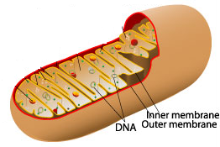

### Identify the organelle above. *Mitochondria* (1 mark)

### Skeletal muscle cells contain many of these organelles. Explain why this is the case.

* Skeletal muscles require a lot of energy
* Energy is acquired from cellular respiration
* Cellular respiration occurs in the mitochondria

(3 marks)

1. Using either a word or chemical equation, describe the chemical reaction that would occur within the organelle above and explain how this can result in the formation of ATP.

* Cellular respiration would occur in the mitochondria to produce energy and can be summarized as follows
* glucose + oxygen → carbon dioxide + water + energy OR
* C₆H₁₂O₆ + 6O₂ → 6CO₂ + 6H₂O + energy (1 mark)
* The energy is used to form ATP from ADP (1 mark)

(2 marks)

The following hypothetical cells are cuboidal in shape, with the length, breadth and heights as indicated.

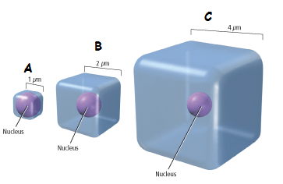

1. Which of the cells in the diagram above (A, B or C) would have the **smallest** surface area to volume ratio?

* C (1 mark)

1. Which of the cells in the diagram above (A, B or C) would supply its organelles with the substances they require most efficiently? Explain your reasoning.

* Cell “A” (1 mark)
* Cell “A” has the greatest surface area to volume ratio (1 mark)
* Cell “A” has the least distance between the cell membrane and the center of the cell, (1 mark)
* so nutrients and wastes can move in and out of the cell the fastest (1 mark)

(4 marks)

1. Name two (2) inputs and two (2) outputs of typical animal cells.

Inputs Oxygen, monosaccharides/glucose, amino acids, tricylcerides/fatty acids/glycerols, water, ions/salts. (1 mark for 2 correct)

Outputs Carbon Dioxide, Lactic acid, ions/salts, water, urea, ammonia/nitrogenous wastes. (1 mark for 2 correct)

(2 marks)

**Question 32 (15 marks)**

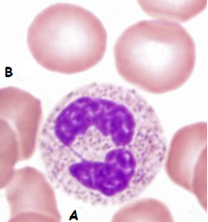

1. Looking at the picture above, state which of the four main tissue types is being shown.

Connective Tissue (1 mark)

1. Provide a reason for your answer in part (a).

* The cells are not close together / separated by non-cellular material/matrix / do not occur on free surfaces (any 1, 1 mark)

(1 mark)

1. Identify each of these cells and state their basic function.
2. Leucocyte / White blood cells / neutrophils (1 mark)

Function: destroying pathogens / phagocytosis of pathogens (1 mark)

1. Red blood cells/erythrocytes (1 mark)

Function: combine with/carry oxygen to cells (1 mark)

(4 marks)

1. Describe three (3) reasons why the cells labeled with a “B” in the picture above are well suited to their function.

Any 3 of the following 4 reasons.

1. Contains haemoglobin (1), which is able to combine with oxygen (1)
2. Does NOT contain a nucleus (1), leaving more room for haemoglobin (1)
3. Biconcave shape (1) provides greater surface area for oxygen to combine with haemoglobin (1)
4. Thick edges gives larger volume (1) so haemoglobin can combine with more oxygen (1)
5. Flexible due to biconcave shape (1) therefore able to fit through capillaries (1)

(6 marks)

1. With reference to the lymphatic system, explain why exercising can reduce the chances of you getting a bacterial infection.

(3 marks)

* Muscle contractions / increased heart rate, increases the rate at which lymph moves through the lymphatic system (1 mark)
* The lymph will circulate through the numerous lymph nodes more often

(1 mark) and

* Therefore increasing the chances of any pathogens being deactivated by macrophages/lymphocytes (1 mark)

**Question 33 (13 marks)**

The diagram shown below is a representation of the human digestive system.

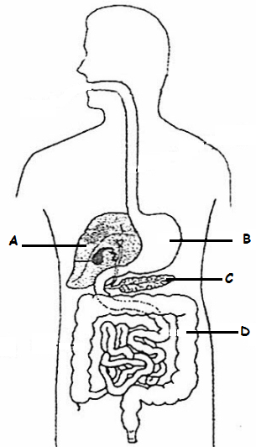

(a) State one (1) function for each of the parts listed in the above diagram. (4 marks)

A: Deamination / hydrolyses of alcohol / gluconeogenesis / bile production / albumin production. (Any 1 for 1 mark)

B: Mechanical digestion / Chemical digestion of protein / absorption of alcohol/ absorption of some drugs or aspirin / storage of food as it is eaten (Any 1 for 1 mark)

C: Production of pancreatic juices/enzymes/protease/amylase/lipase / Production of hormones (insulin/glucagon). (Any 1 for 1 mark)

D: Water absorption / site for decomposition of remaining organic material by bacteria / vitamin production via bacteria (Any 1 for 1 mark)

(b) Chinese swimmer Sun Yang holds the world record for the 1500m men’s freestyle with a time of 14 minutes and 31 seconds. Detail the main cellular respiration system that he would rely on during the race.

Any of the following worth 1 mark.

Respiration is a series of reactions in which energy is released from *glucose* (1). **Aerobic respiration** (1) is the form of respiration which uses oxygen (1). It can be summarised by this equation:

**glucose + oxygen** → **carbon dioxide + water (+ energy)**

or C6H12O6 + 6O2 → 6CO2 + 6H2O + ENERGY with explanations

Energy is shown in brackets because it is not a substance. Notice that:

* Glucose and oxygen are used up (1)
* Carbon dioxide and water are produced as waste products (1)

Aerobic respiration happens all the time in the cells of animals. Most of the reactions involved happen inside **mitochondria** (1), tiny organelles inside the cytoplasm of the cell. The reactions are controlled by *enzymes* (1)

During exercise, the muscle cells respire more than they do at rest. This means that:

* Oxygen and glucose must be delivered to them more quickly
* Waste carbon dioxide must be removed more quickly

This is achieved by increasing the **heart rate**, **rate of breathing** and the **depth of breathing**.

Annotated diagram with explanations OK

[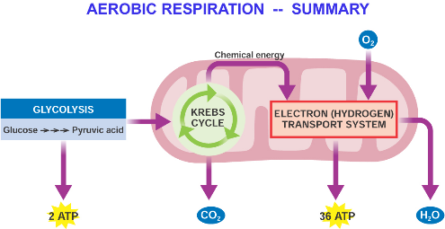](http://www.google.com.au/url?sa=i&rct=j&q=&esrc=s&frm=1&source=images&cd=&cad=rja&uact=8&ved=0ahUKEwiBz-en8_PMAhVkJKYKHTTwCJQQjRwIBw&url=http://www.memrise.com/mem/3506470/aerobic-respiration/&psig=AFQjCNFEvZ2SXbwbbFv6OBCpQHFX2FggnQ&ust=1464220071868719).

1mark

1markk

1mark

(5 marks)

**The** **diagrams below show structures found in the small intestine and lungs.**

Structural Feature 1 Structural Feature 2

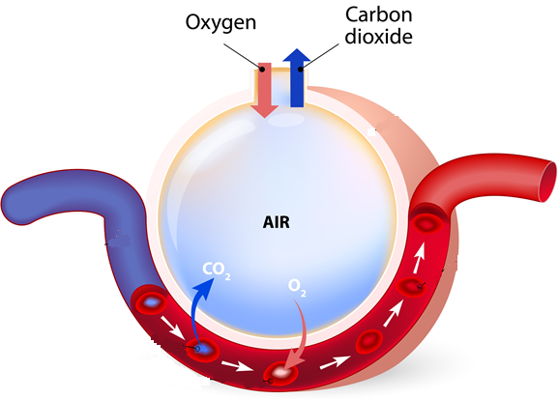

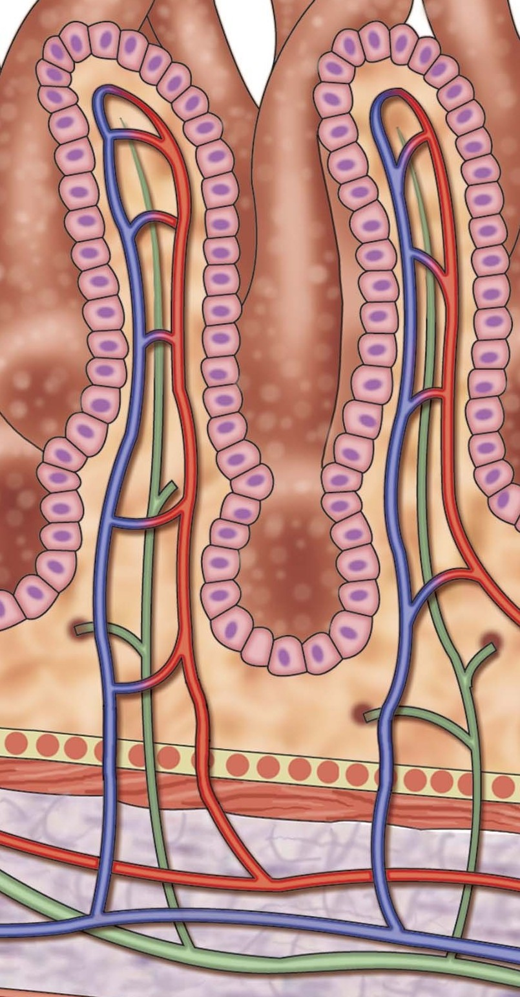

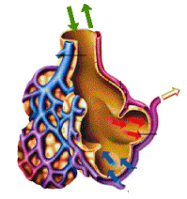

The exchange surfaces of the small intestine and lungs rely on concentration differences so that substances can cross the surfaces rapidly and constantly.

(c) Identify structural features 1 and 2 and describe four (4) similarities that allow them to maintain the concentration gradient.

(6 marks)

* Structural feature 1: Villi of the small intestine. (1 mark)
* Structure feature 2: alveoli (1 mark)
* Both features are covered with a single layer of cells, so the nutrients in the villi and the oxygen in the alveoli, do not have to travel far to move into the blood stream (1 mark)
* Both features are covered with a network of blood capillaries, so that as much blood as possible is close to the nutrients in the villi / oxygen in the

alveoli (1 mark)

* The shape of the villi and the alveoli generate a large surface area for the nutrients/gases to be rapidly exchanged in a short amount of time (1 mark)
* The blood flow through the capillaries is rapid, maintaining the concentration gradient (1 mark)

**Question 34 (15 marks)**

This question refers to the diagram shown below.

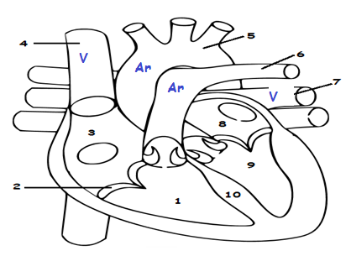

1. Identify the above labeled structures:

|  |
| --- |
| 1. *Right Ventricle* (1 mark) |
| 2. *Atrioventricular valve/Tricuspid valve* (1 mark) |
| 7. *Pulmonary vein* (1 mark) |
| 8. *Left Atrium* (1 mark) |
| 10. *Septum* (1 mark) |

(5 marks)

1. What are the functions of structures 2, 5 and 6?

Structure 2: Stop blood flowing back into Right Atrium (1 mark)

Structure 5: Guide blood to rest of body. (1 mark)

Structure 6: Guide blood to lungs. (1 mark) (3 marks)

1. Label all the veins and arteries on the diagram above, with a “V” and an “Ar” respectively.

* 1 mark all veins labelled.
* 1 mark all arteries labelled

(2 marks)

1. How does the heart muscle receive nutrients and remove metabolic wastes?

Via the coronary arteries and coronary veins, respectively. (1 mark)

(e) Arteries differ in structure and function to that of the veins.

Give two (2) structural differences and one (1) functional difference between arteries and veins.

Any 2 of the following STRUCTURAL differences, 1 mark each.

* Arteries have thick / elastic muscular walls, veins have thin / non-muscular / inelastic walls.
* Veins have valves, arteries do not.
* Veins have a wide lumen/ arteries have a narrow lumen

Any 1 of the following FUNCTIONAL differences, worth 1 mark.

* Arteries carry blood away from the heart; veins carry blood to the heart.
* Arteries have a higher blood pressure; veins have a low blood pressure.
* Arteries blood pressure changes with cardiac cycle, veins have relatively constant blood pressure.

(3 marks)

**Question 35 (12 marks)**

Study the diagram below and answer the questions that follow.

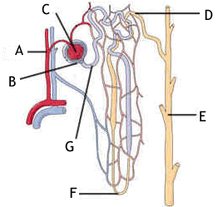

1. Provide labels for structures:

A Renal arteriole

B Glomerular capsule (Bowman’s capsule)

E Collecting Tubule

F Loop of Henle

(4 marks)

(b) Briefly explain how the afferent arteriole and efferent arteriole assist Structure C to carry out its function.

The afferent arteriole leading to the glomerulus has a wider diameter than the efferent arteriole leaving it (1). This narrowing of the efferent arteriole increases resistance to the flow of blood and produces a higher pressure in the glomerulus, forcing the fluid out, through the capsule (1)

(2 marks)

Water is reabsorbed via the cells that line the whole length of the nephron. The method of transport used to absorb the water in the proximal convoluted tubule (PCT) and Loop of Henle is different to the method used in the distal convoluted tubule (DCT) and collecting duct (CD).

(c) State which of the four tissue types the cells that regulate water reabsorption could be classified into.

Epithelial tissue (1mark) (1 mark)

(d) Explain how water molecules move from the PCT and Loop of Henle into the blood stream.

* Water molecules move passively/ without using energy (1 mark)
* from an area of high concentration to an area of low concentration (1 mark)
* via osmosis through a channel protein (1 mark)

(3 marks)

**Question 36 (20 marks)**

In the 1960s a doctor working for the Red Cross in the Congo region of Africa, saw pregnant women drinking tea from the leaves of the Kalata-Kalata plant. These women believed that drinking the tea increased the speed at which they gave birth.

Scientist later discovered that a protein (named Kalata B1) in the leaf caused the contractions of the uterus in women. In an effort to help women who were overdue, scientists wanted to find out what concentration of Kalata B1 was needed to start contractions in women, who were in their 41st week of pregnancy, as soon as possible after consuming the tea.

Five different concentrations of Kalata B1were tested. Each concentration was tested on 5 different women, who were all tested in the one hospital.

The results from this experiment can be seen below.

|  |  |  |  |  |  |  |
| --- | --- | --- | --- | --- | --- | --- |
| Concentration of Kalata B1 (g/mL) | Time elapsed before contractions started (seconds) | | | | | |
| Trials | | | | |  |
| 1 | 2 | 3 | 4 | 5 | Average |
| 0.01 | 35 000 | 38 000 | 36 500 | 33 240 | 37 005 | 35 949 |
| 0.02 | 28 000 | 27 000 | 26 980 | 29 009 | 27 101 | 27 618 |
| 0.03 | 26 000 | 27 809 | 25 807 | 26 500 | 27 709 | 26 765 |
| 0.04 | 23 000 | 22 908 | 23 776 | 22 809 | 23 005 | 23 100 |
| 0.05 | 18 000 | 17 986 | 18 203 | 18 246 | 18 009 | 18 089 |

1. Write a suitable hypothesis for this experiment. (1 mark)

* Provide a definite statement with only ONE independent variable that can be tested.
* The effect the independent variable will have on the dependent variable is predicted.

E.g. If the concentration of Kalata B1 is increased, then the average time that will elapse before the contractions begin will decrease.

1. Name the:
2. Independent variable Concentration of Kalata B1(1 mark)
3. Dependent variable Time elapsed before contractions

started (seconds) (1 mark) (2 marks)

1. Calculate the average time elapsed for the 0.05 g/mL Kalata B1 concentration and place it in the table above.

18089 (1 mark)

1. Plot the results on the graph paper supplied on the next page. (5 marks)

* Graph should show a linear negative correlation.
* Bar graph (minus 1 mark, data is continuous)
* Line graph drawn (1 mark)
* Title with independent and dependent variable (1 mark)
* Independent variable on x axis and labelled (1 mark)
* Dependent variable on y axis and labelled (1 mark)
* Numbers scaled appropriately on the axis (1 mark)

1. Two groups should be used in any experiment. State the name of the two groups and explain how they are different to each other.

* Experimental (1 mark) and Control group (1 mark)
* The experimental group has the independent variable and the control group has all the same conditions as the experimental group, but does not have the independent variable / has a placebo (1 mark)

1. marks)
2. A placebo should have been used as this experiment was trialing a drug.

Define what a placebo is and describe how it should have been used in this experiment.

A placebo is an inactive substance / has no effect, that looks and tastes like the tested

drug (1 mark). In this experiment, a drink of tea that looks and tastes like the Kalata B1 tea (1 mark) needed to be provided to a control group (1 mark).

(3 marks)

1. Excluding the placebo, name a controlled variable that was used in this experiment and explain why it was used.

* To gain 1 mark, all of the following listed controlled variables need to be supported by a reasonable and valid reason as to why they were used.
* The type of drug being used, Kalata B1.
* The number of weeks the lady has been pregnant / 41 weeks pregnant.
* The hospital the women were patients in.
* When the timer is started, after the women has drunk the medicine/tea.
* Drug / placebo only administered as a cup of tea / consumed as a liquid.

(2 marks)

1. The same factors that influence the activities of enzymes, affect proteins.

Explain two (2) reasons why scientists were amazed that the Kalata B1 protein remained active and had an effect on the women’s uterus.

Despite being exposed to:

* high temperatures when boiled in the tea (1 mark) and
* the acidic conditions in the stomach (1 mark),
* the protein was not denatured and still had an effect (1 mark).

(3 marks)

**Question 37 (12 marks)**

(a) Fill in the table showing the basic units that make up the nutrients listed

|  |  |
| --- | --- |
| **Nutrient** | **Basic Units** |
| Carbohydrates | Glucose |
| Proteins | Amino acids |
| Lipids | Fatty acids and glycerol |

(3 marks)

(b) Foods such as white bread and pasta are predominantly composed of complex carbohydrates. Explain how your digestive system breaks down these complex carbohydrates chemically. Include in your answer the structures and specific enzymes involved.

**Carbohydrate digestion** begins in the mouth (1). The salivary glands in the mouth secrete saliva (1), which helps to moisten the food. The food is then chewed while the salivary glands also release the enzyme salivary amylase (1) speeding up hydrolysis (1), which begins the process of breaking down the polysaccharides (1) in the **carbohydrate** food (e.g. starch).

Digestion of the carbohydrate does not resume until the food mass reaches the first part of the small intestine that we call the **duodenum** (1). Here the carbohydrate meets the enzymes **pancreatic amylase** (1) and **intestinal amylase** (1), which are similar to salivary amylase, and continues the breakdown of the carbohydrate.

Pancreatic and intestinal amylases breaks the polysaccharide down into a disaccharide (e.g. maltose)(1), a chain made up of units containing only two sugars linked together. The small intestine then produces enzymes called lactase, sucrase and maltase, which break down the disaccharides into monosaccharides (e.g. glucose)(1). The monosaccharides have single unit sugars that are then absorbed in the small intestine.

Max 2 marks for structures involved and 2 marks for enzymes involved (4 marks)

(c) Distinguish between the processes of excretion and elimination and list one organ involved in each process.

**EXCRETION** refers to the REMOVAL of METABOLIC WASTE produced in the body (1). **ELIMINATION** refers to the REMOVAL of INDIGESTIBLE MATERIAL produced in the body (1).

Organs involved in excretion – Lungs, Skin, Kidneys and Large Intestines (1)

Organs involved in elimination – Rectum (storage of faecal materials) and Anus (1)

Max 2 marks for defining each process (distinguishing them) and 2 marks for listing an organ involved in each process (4 marks)

**End of Section Two**

**Section Three: Extended answer 20% (40 Marks)**

This section contains **three (3)** questions. You must answer **two (2)** questions. Make sure you clearly indicate which question you are answering and write your answers in the space provided.

Spare pages are included at the end of this booklet. They can be used for planning your responses and/or as additional space if required to continue an answer.

* + Planning: If you use the spare pages for planning, indicate this clearly at the top of the page.
  + Continuing an answer: If you need to use more space to continue an answer, indicate in the original answer space where the answer is continued, i.e. give the page number. Write the number of the question(s) that you are continuing to answer at the top of the additional space page.

Responses could include clearly labeled diagrams with explanatory notes; lists of points with linking sentences; clearly labeled tables and graphs; and annotated flow diagrams with introductory notes.

Suggested working time: 40 minutes.

**Question 38 (20 marks)**

1. Draw and label the structures that have a role in the movement of air into the lungs.

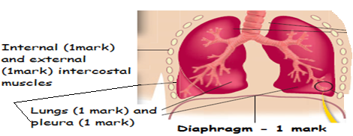

(5 marks)

1. A common war injury is the “Sucking chest” wound. This is where shrapnel or a bullet has penetrated the victim’s sternum and pleura. A hissing sound can be heard as the person attempts to breathe. This injury can be fatal within a few minutes, as their lung(s) will collapse.

Describe the process that normally occurs to increase and decrease the volume of the chest cavity during inspiration and expiration and explain why a “Sucking chest” wound would make breathing physically impossible and cause the collapse of the affected lung.

(10 marks)

To increase the volume of the chest cavity:

* The diaphragm contracts and becomes flatter (1 mark)
* The external intercostal muscles contract and the internal intercostal muscles relax which (1 mark)
* Causes the rib cage to lift upwards and outwards (1 mark)

To decrease the volume of the chest cavity:

* The diaphragm relaxes and bows up (1 mark)
* The internal intercostal muscles contract and the external intercostal muscles relax which (1 mark)
* Causes the rib cage to move downwards (1 mark)
* For air to enter the lungs, the air pressure must be less inside the chest cavity than the outside (1 mark)
* If there is a hole in the sternum/pleura the air pressure is equalised and the lungs cannot fill with air. (1 mark)
* If the lungs are detached from the pleura, then the lungs cannot expand as the rib cage moves upwards/outwards (1 mark)
* As a result, the lungs cannot fill with air and they collapse (1 mark)

1. Describe the process that can lead to the development of a “smoker’s cough” and explain how the “smoker’s cough” can lead to the sufferer developing emphysema. Explain why the sufferer needs to consciously make an effort to exhale.

(5 marks)

* Inhaled smoke particles constantly irritate the mucous membranes that line the air passages, this results in excessive mucus (1 mark)
* Accumulating mucus cannot be removed, causing “smoker’s cough”. (1 mark)
* Irritating particles damage alveoli and they are replaced with

scar/fibrous tissue. (1 mark)

* Alveoli lose their elasticity and so the lungs are constantly inflated (1 mark)
* Breathing out no longer occurs passively, but requires a voluntary effort (1 mark)

**Question 39 (20 marks)**

Unlike single celled organisms such as amoeba, the human body has a very complex circulatory system that deals with the delivery and removal of many substances to and from the body.

(a) Explain how our circulatory system delivers oxygen and nutrients to and removes wastes from the cells of the human body.

Most living organisms perform respiration, the breakdown of food products to release energy in the presence of oxygen (1).

Haemoglobin (frequently abbreviated as Hb), which is contained in red blood cells, serves as the oxygen carrier in blood (1) from the lungs to the tissues.

Haemoglobin also plays a major role in the transport of carbon dioxide from the tissues back to the lungs (1).

When inhaling, oxygen in the lungs passes through the thin-walled blood vessels and into the red blood cells, where it binds to the haemoglobin, turning it into the bright red [oxy-haemoglobin](http://www.chm.bris.ac.uk/motm/hemoglobin/oxyheme.pdb) (1).

The blood then passes around the body until it reaches cells and tissues which require oxygen to sustain their processes (1). These cells are rich in CO2, which is a waste product of these processes (1). The CO2 displaces the weakly-bound O2 and forms carbaminohaemoglobin (1), which then travels in the bloodstream back around to the lungs where it is again displaced by oxygen.

Therefore both O2 and CO2 bind *reversibly* to haemoglobin (1).

Carbon dioxide is more soluble in blood than is oxygen (1). About 5 to 7 percent of all carbon dioxide is dissolved in the plasma (1) as bicarbonate ions (1).

The formation of bicarbonate ions, (HCO3-) takes place by the following reactions:

Hydration of CO2: CO2 + HOH === H2CO3  
Dissociation of H2CO3: H2CO3 === H+ + HCO3-

Combined into one equation as follows:  
CO2 + HOH <===> H2CO3 <===> H+ + HCO3- (1)

This process occurs rapidly in the red blood cells because a high concentration of the enzyme carbonic anhydrase catalyzes the reaction (1).

Plasma isthe [liquid](http://www.britannica.com/science/liquid-state-of-matter) portion of [blood](http://www.britannica.com/science/blood-biochemistry). Plasma serves as a transport medium for delivering nutrients (1) to the cells of the various organs of the body and for transporting waste products derived from cellular metabolism to the kidneys, liver, and lungs for excretion (1).

Important constituents of plasma include electrolytes such as sodium, potassium, chloride, bicarbonate, magnesium, and calcium (1). In addition, there are trace amounts of other substances, including amino acids, vitamins, organic acids, pigments, and enzymes (1). Hormones such as insulin, corticosteroids, and thyroxine are secreted into the blood by the [endocrine system](http://www.britannica.com/science/endocrine-system). Plasma concentrations of hormones must be carefully regulated for good health. Nitrogenous wastes (e.g., [urea](http://www.britannica.com/science/urea) and creatinine) transported to the kidney (1).

Any reasonable 12 points

(12 marks)

(b) Use a summary of the ABO and Rh blood groups, showing the antigens and antibodies present in each group, to explain why an adverse reaction occurs when incompatible blood types are mixed. State why people with blood type O negative can donate their blood to anyone, whereas people with blood type AB positivecan receive blood from anyone.

|  |  |  |
| --- | --- | --- |
| Blood group | Antigens on RBC | Antibodies in plasma |
| A | Antigen A | Antibody B |
| B | Antigen B | Antibody A |
| AB | Both Antigen A and B | No antibodies |
| O | No antigens | Both antibodies |
| Rh+ | Rh antigen | No anti Rh antibody |
| Rh- | No Rh antigen | Anti Rh antibody |

* *No ½ marks awarded. 1 mark deducted for each incorrect blood group. Maximum 4 marks.*
* The reaction is called agglutination / red blood cells/erythrocytes clump together (1 mark)
* It happens when the receiver’s blood has antibodies present in the plasma that react with the antigens on the donors blood cells and they cause the foreign red blood cells to clump together (1 mark).
* People with blood type O- can donate to anyone as they do not have any antigens on the surface of their red blood cells, so they do not trigger an immunity response in a recipient. (1 mark)
* People with AB+ can receive blood from anyone as they do not have any antibodies that will respond to any antigens present on any blood cells that may receive. (1 mark)

(8 marks)

**Question 40 (20 marks)**

There are six main methods in which materials are transported across cell membranes.

1. Describe how four (4) of these methods occur, the type of material that is transferred and a specific example of where it occurs in the body.

*Any 4 methods, 3 marks each.*

|  |  |  |  |
| --- | --- | --- | --- |
| **Method** | **How method occurs** | **Body part** | **Type of material** |
| Diffusion | * Liquid/gas particles randomly move from an area of high to low concentration. * Particles keep moving until they have evenly spaced themselves out in the available area.   (1 mark) | * PCT and Loop of Henle of kidneys. * Alveoli of lungs * Villi of small intestine * Mouth and Stomach wall * Large intestine   (1 mark) | * Oxygen and carbon dioxide. * Alcohol * Fat soluble vitamins.   (1 mark) |
| Facilitated diffusion | * Particles move from an area of high to low concentration THROUGH a carrier protein. * Particle binds to carrier protein, protein changes shape and moves particle to other side.   (1 mark) | * Kidneys * Small intestines, * Liver   (1 mark) | * Substances that are too large to fit through the plasma membrane, such as glucose / amino acids.   (1 mark) |
| Osmosis | * The movement of a solvent (usually water) from an area of high to low concentration THROUGH a semi-permeable membrane.   (1 mark) | * Kidney nephrons and small intestines. * All cells of the body. * Large intestines * Stomach wall   (1 mark) | * Water.   (1 mark) |
| Active transport | * Liquid/gas particles move from an area of low to high concentration across the cell membrane. * Large molecules are taken across the cell membrane via carrier proteins   (1 mark) | * PCT * Small intestine/villi * Kidneys * Small intestines, * Liver * Fat soluble molecules through any cell membrane.   (1 mark) | * Glucose * Amino acids * Na+ / K+ * Steroids * Some vitamins.   (1 mark) |
| Endocytosis | * When a cell surrounds some extracellular material with a fold of the cell membrane. * The enfolding membrane then breaks away, and the material is enclosed within the cell in the form of a small membrane-bound vesicle. * Two types, phagocytosis (solid engulfing) and pinocytosis (liquid engulfing).   (1 mark) | * White blood cells/leucocytes. * All cells carry out pinocytosis, therefore any organ.   (1 mark) | * Pathogens * Any liquid.   (1 mark) |
| Exocytosis | * When the contents of a vesicle are pushed out through the cell membrane. * The membrane around the vesicle fuses with the cell membrane and the vesicle contents are passed to the exterior.   (1 mark) | * Mammary glands. * Saliva glands * Pancreas * Liver * Gastric pits. * Hormonal /endocrine gland.   (1 mark) | * Milk * Saliva * Digestive enzymes * Hormones   (1 mark) |

(12 marks)

1. There are three main processes that occur in a nephron: Filtration, Selective Reabsorption and Tubular Secretion. Briefly describe each of these processes and how each contributes to the final composition of urine.

**Glomerular Filtration** [by ‘bulk flow’/ pressure (1)]

Approximately 16% to 20% of the blood plasma that enters the kidney is filtered from the glomerular capillaries into the Bowman’s capsules of the nephron, as glomerular filtrate (1). The kidneys produce approximately 180 litres of glomerular filtrate per day of which 99% is reabsorbed from the renal tubules i.e. 1% - 1or 2 litres per day excreted as urine (1).

The internal portion of the Bowman’s capsule is 100X to 1000X more permeable than a typical capillary (1). Water and solutes of small molecular dimension pass freely from the plasma into the Bowman’s capsules (1) but, relatively impermeable to large molecules such as plasma proteins (1) making the filtrate basically protein free.

**Tubular Reabsorption** [can be passive or active (1)]

Many plasma components that have been filtered from the glomerular capillaries into the Bowman’s capsules are reabsorbed from the renal tubules into the peritubular capillaries (1), especially water and many inorganic ions (1). For example glucose, amino acids, vitamins and sodium, calcium and chloride ions are reabsorbed actively (1), while urea (due to the reabsorption of water) is passively reabsorbed (1).

Since carrier molecules may be involved, these may become saturated if a substance increases substantially and as a result will not be able to reabsorb all of the substance (1).

**Tubular Secretion** [can be passive or active (1)]

Move substances that leave the peritubular capillaries into the renal tubules (1). For example hydrogen, potassium ions and penicillin (1) are secreted this way.

**Max of 3** marks per process (any two processes) and 2 marks for the other process described.

. (8 marks)

**END OF QUESTIONS**

References

Question 11

File:2611_Blood_Flow_in_the_Nephron.jpg. Retrieved November 17, 2015, from [https://commons.wikimedia.org/wiki/File:2611_Blood_Flow_in_the_*******.jpg#filelinks](https://commons.wikimedia.org/wiki/File:2611_Blood_Flow_in_the_*******.jpg#filelinks)

Question 31(a)

Organelle jpg. Retrieved November 17, 2015, <https://adapaproject.org/bbk_temp/tiki-index.php?page=Leaf%3A+How+does+the+electron+transport+chain+provide+cells+with+energy%3F>

Question 31 (d)

Cell%20Surface%20to%20volume.gif Retrieved October 24, 2015, from. <http://baileyb.pbworks.com/f/1391453862/Cell%20Surface%20to%20volume.gif>

Question 32

Image by Spike Walker in Wellcome Images under the Creative Commons license   
[CC BY-NC 3.0 AU](http://creativecommons.org/licenses/by-nc/3.0/au/)

Question 33 (a)

55026021948267c7c5d943. Retrieved October 17, 2015, from <http://www.oldschool.com.sg/modpub/55026021948267c7c5d943>.

Question 33 (c)

Retrieved January 17, 2016 from

Image, used under license from Shutterstock.com

Question 33 (c)

Top picture.

Retrieved January 17, 2016 from

Image, used under license from Shutterstock.com

Question 33 (c)

Bottom picture.

Pic45.gif

<http://www.mcqueens.net/mcqueen-ntl/dis/toc_/Pt20.html>.

Question 34

images?q=tbn:ANd9GcSS_bhcvEHHsehEmokG61-MCNLrAleEO3I5JvYknT7U4oSlhaWcEQ

[http://freecoloringpages.co.uk/?q=h****%20parts%20not%20labeled](http://freecoloringpages.co.uk/?q=h****%20parts%20not%20labeled)

Question 35 (a)

n_lettered.gif. Retrieved October 17, 2015, from

https://en.wikipedia.org/wiki/G*********_(k*****)

Question 37

Sliding-Filament_Theory.jpg. Retrieved January 19, 2016, from <https://ehumanbiofield.wikispaces.com/musclehomeworking>

Question 38

Picture of lungs, present in answer key only.

Retrieved January 19, 2016, from

Newton, T. and Joyce, A. (n.d.). *Human perspectives units 1 & 2*. pg. 99.